Project- 2 - Milestone task  
  
  
  
Step – 1 :- open the terminal  
Step – 2 : -check git is installed or not if not then sudo apt update ~~- >~~ sudo apt-get install git

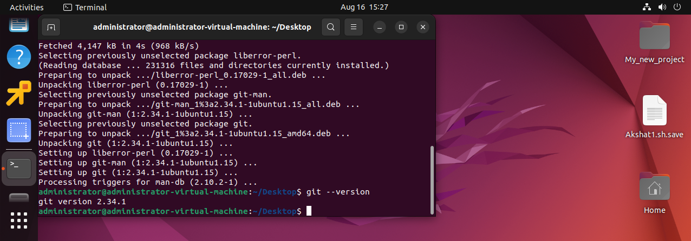

Step- 3:- Git is installed in my local server  
  
-> mkdir with process.check.sh

-> cd process.check.sh

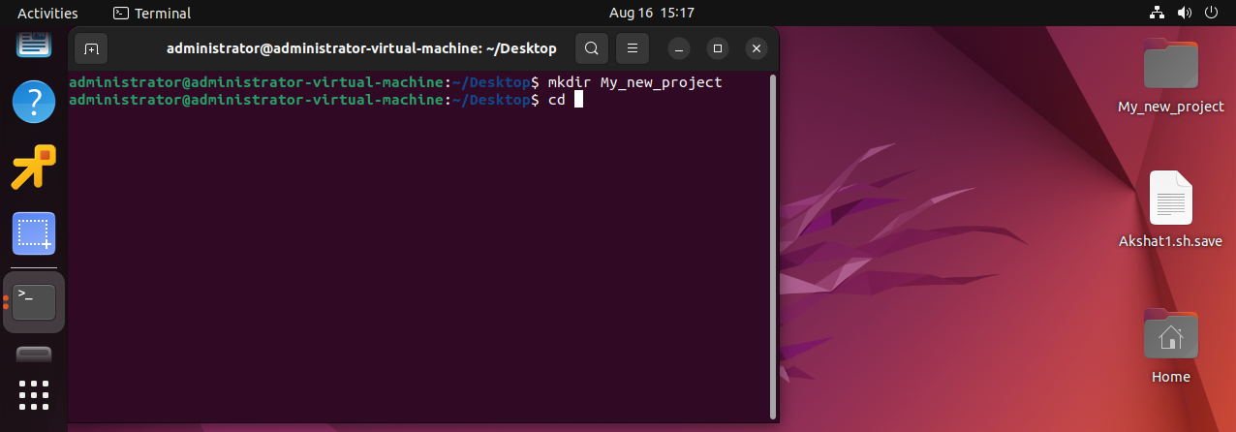

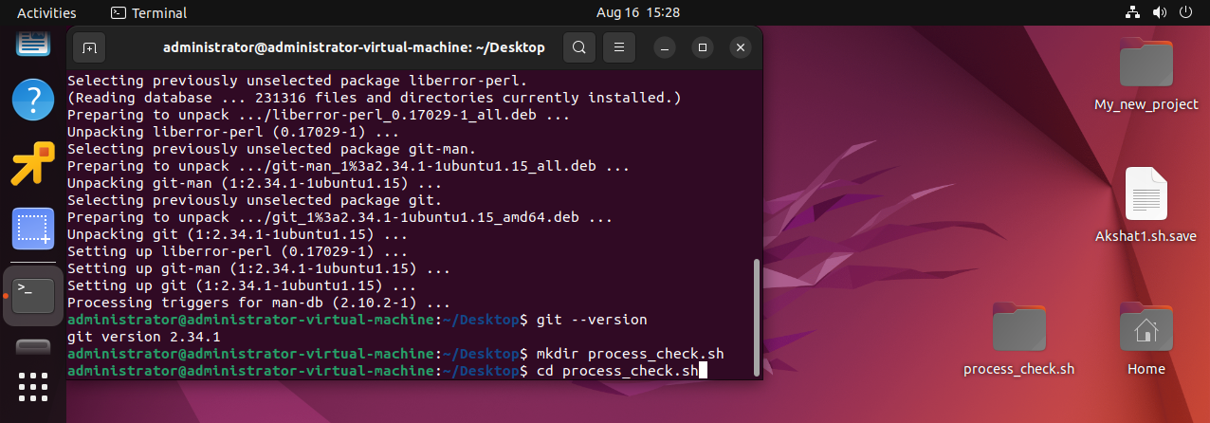  
  
step- 4 :- git init – to initilize the files

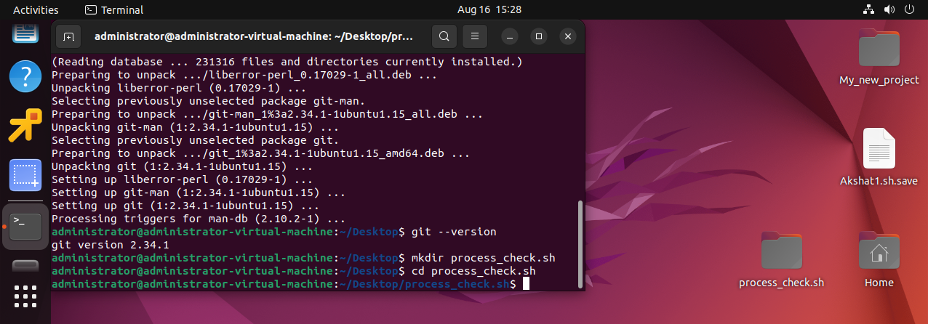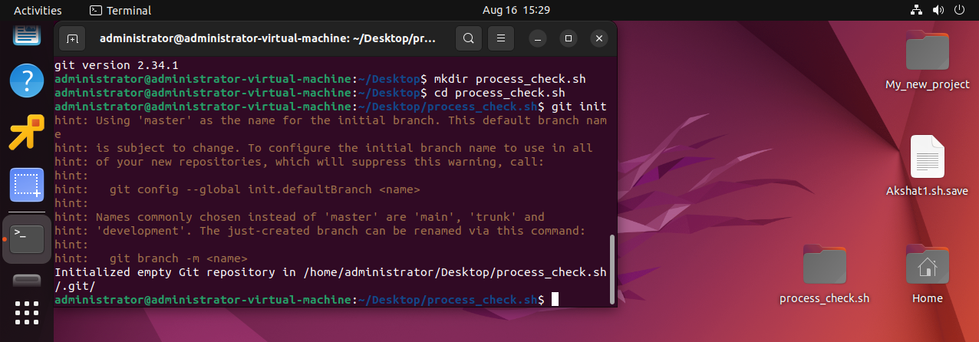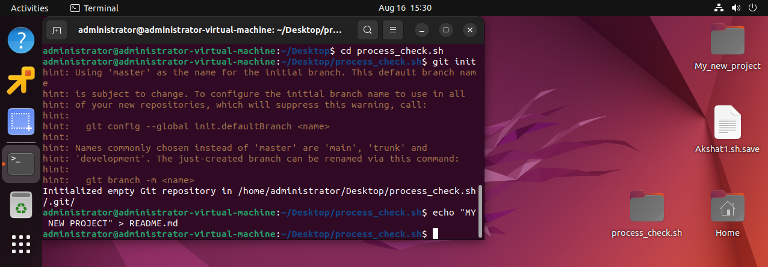  
  
step 5: Git add . = this command will read and all the file in the folder.  
 Git commit -m “initial commit is” == to commit the changes in local server

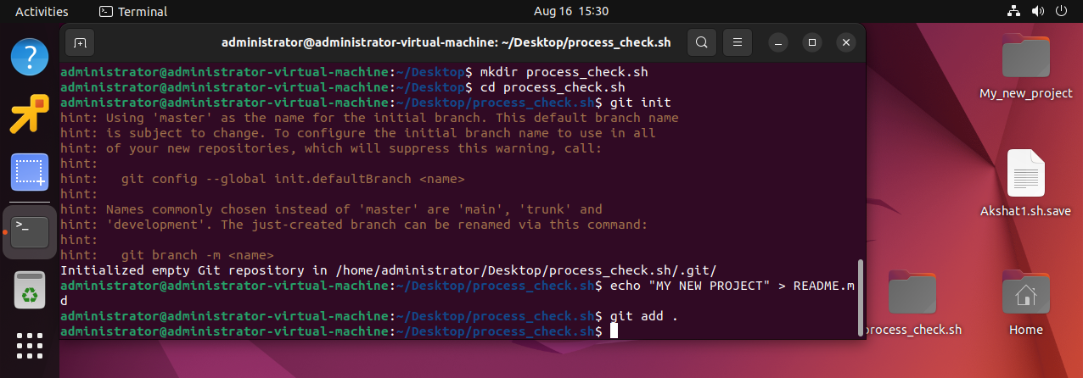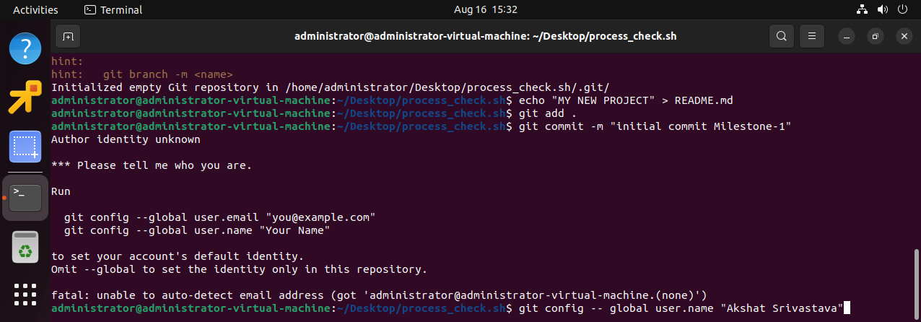  
step – 6 :- add the user name and user email.id then commit the changes to local server

username- Akshat Srivastava

email id :- akshatsri999@gmail.com

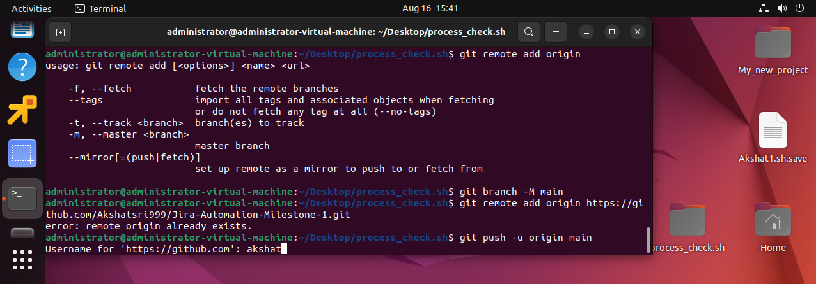

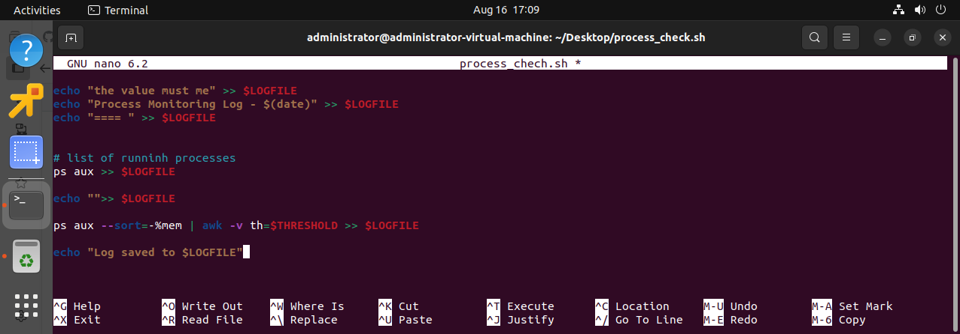

S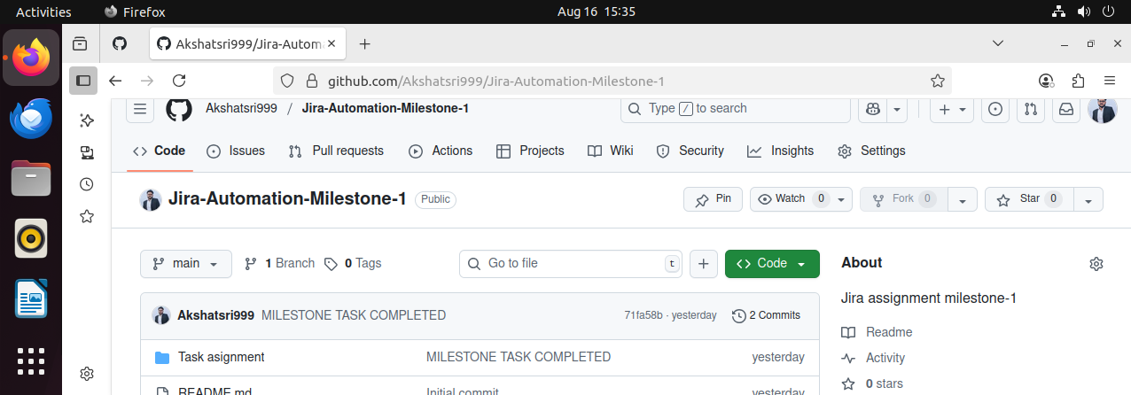tep – 7 after entering the username and password of git hub account.  
 Git push origin main –force == when i create the token in github account  
 git push origin main == git code is pushed to Akshatsri999 account.

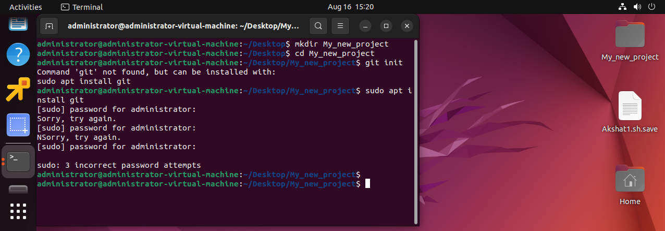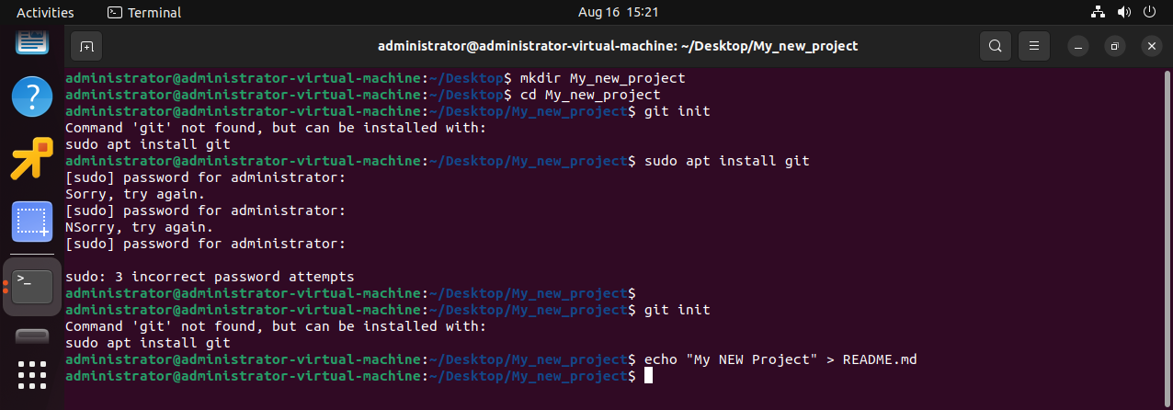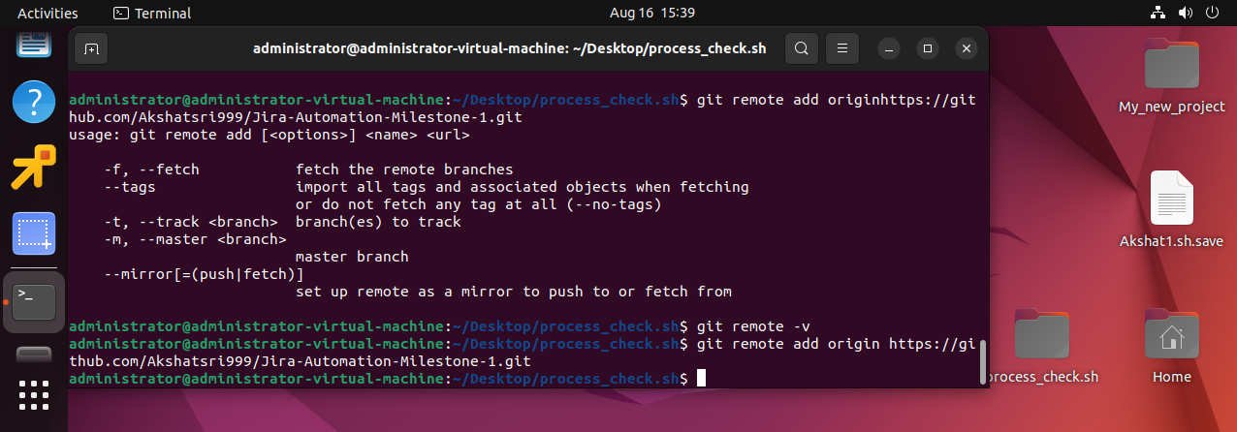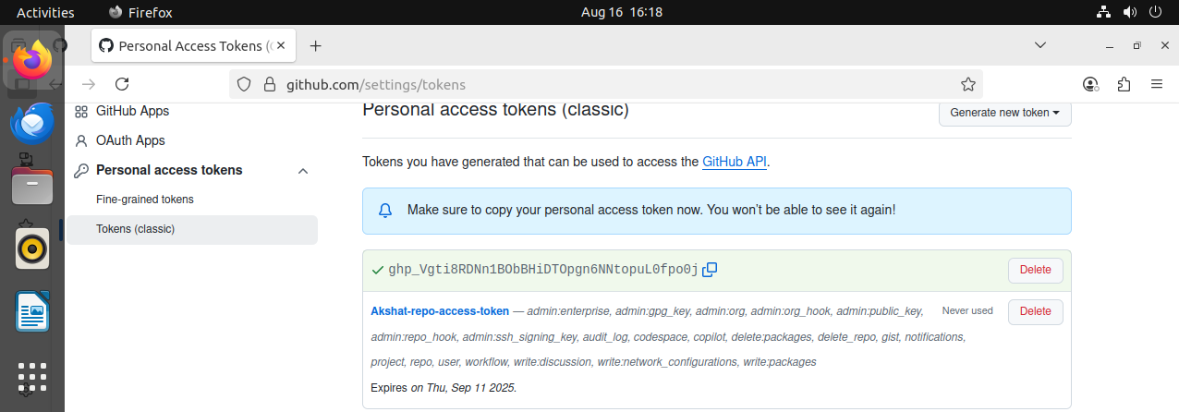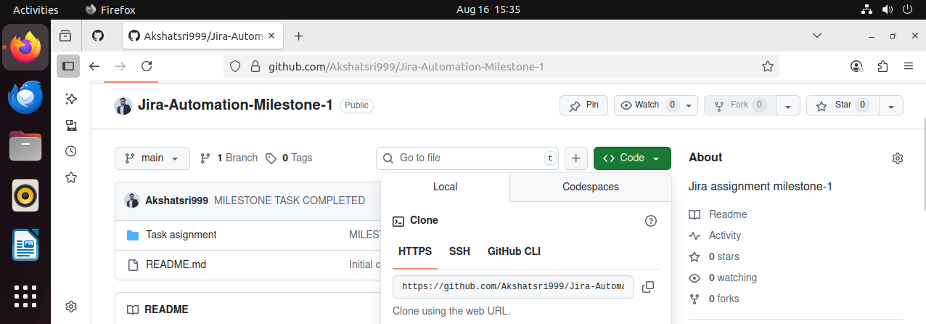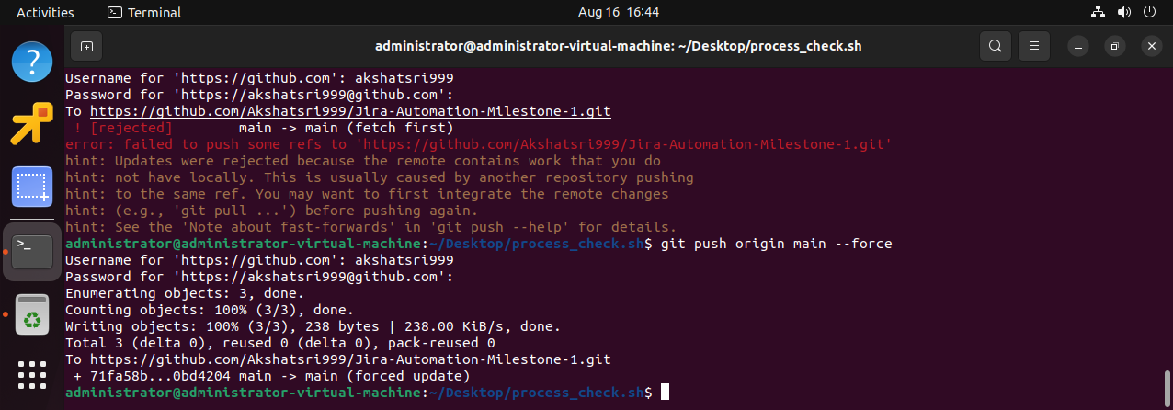  
Step- 8 github token generation ss attached.

  
Step- the code and file is pushed to the github remository   
  
  
link to access the performed work: -

https://github.com/Akshatsri999/Jira-Automation-Milestone-1.git